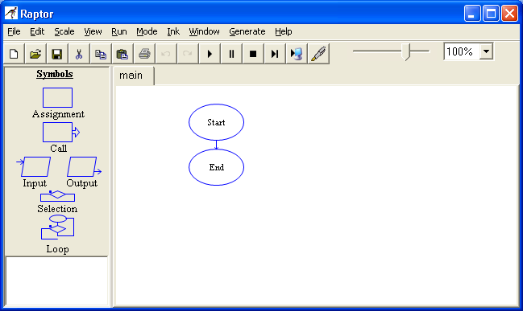
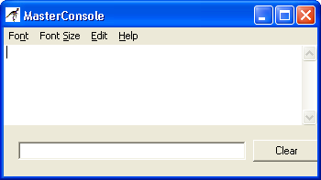
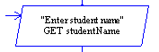
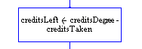
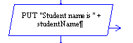
Learning Objectives:
- Understand algorithms
- Create algorithms, pseudocode, flowchart, and IPO charts
- Understand the concepts of input, processing, and output

1 – Algorithms

This activity requires you to think about the steps that take place in a program by writing algorithms. Read the following program prior to completing the activity.

Write a program that will take in basic information from a student, including student name, degree name, number of credits taken so far, and the total number of credits required in the degree program. The program will then calculate how many credits are needed to graduate. Display should include the student name, the degree name, and credits left to graduate.

Step 1: Examine the following algorithm. (Reference: Designing a Program, page 31).

- Get the student name.
- Get the degree program name.
- Subtract the number of credits taken so far from the required credits for the degree.
- Get the number of credits required for the degree program.
- Get the number of credits the student has taken so far.
- Display the input information in Step 1 and 2.
- Display the calculated information.

Step 2: What logic error do you spot and how would you fix it?
Step 3 needs to go after step 4 and 5.

Step 3: What steps require user interaction (Ex: user must type in some input)?
Student Name and Program name

2 – Pseudocode

This lab requires you to think about the steps that take place in a program by writing pseudocode. Read the following program prior to completing the lab.

Write a program that will take in basic information from a student, including student name, degree name, number of credits taken so far, and the total number of credits required in the degree program. The program will then calculate how many credits are needed to graduate. Display should include the student name, the degree name, and credits left to graduate.

Step 1: This program is most easily solved using just five variables. Identify potential problems with the following variables declared in the pseudocode. Assume that the college has the ability to offer half credits. (Reference: Variable Names, page 39-40).

Variable Name | Problem (Yes or No) | If Yes, what’s wrong?
Declare Real creditsTaken | No
Declare Real credits Degree | Yes | No spaces
Declare Int creditsLeft | Yes | Real
Declare Real studentName | Yes
Declare String degreeName | No

Step 2: Create an IPO chart for the solution.
Input | Process | Output
Declare Real creditsDegree  Declare String studentName  Delcare String studentName | -

Step 3: Complete the pseudocode by writing the two missing lines. (Reference: Prompting the User, page 42).

Display “Enter student name.”
Input studentName
Display “Enter degree program.”
Input degreeName
Display “Enter Degree Credit.”
Input creditsDegree
Display “Enter the number of credits taken so far.”

Step 4: Write the exact output you would expect from the following line of code if the user of the program enters “Bill Jones”. (Reference: Displaying Items, page 40 – 41).

Display “The student’s name is “, studentName
The student's name is Bill Jone

Step 5: Write the exact output you would expect from the following line of code if the user of the program enters a degree that is 63 credits in total and they have taken 40 credits. (Reference: Displaying Items, page 40 – 41).

Display “This program requires “, creditsDegree, “ credits and they have taken “, creditsTaken, “ so far.”
This program requires 63 credits and they have taken 40

Step 6: Complete the following pseudocode to solve the programming problem.

- //This program takes in student information and calculates
- //how many credits the student has left before graduation.
- //Information is then printed to the screen.

- //Declare variables
- Declare Real creditsTaken
- Declare Real creditsDegree
- Declare String studentName
- Declare String degreeName
- Declare Real creditsLeft
- //Ask for user input
- Display “Enter student name.”
- Input studentName
- Display “Enter Program name.”
- Input degreeName
- Display “Enter Credits Taken.”
- Input creditsTaken
- Display “Enter Credits for Degree.”
- Input creditsDegree

- //Calculate remaining credits
- Set creditsTaken – creditsDegree = creditsLeft
- //Display student name, degree program, and credits left.
- Display “The student’s name is “, studentName
- Display “The Degree Program is”, degreeName
- Display “Credits left are”, creditLeft

3 – Flowcharts

This lab requires you to think about the steps that take place in a program by designing a flowchart. While designing flowcharts can be done with paper and pencil, one mistake often requires a lot of erasing. Therefore, a flowcharting application such as Raptor or Visio should be used. This lab will give you a brief overview of Raptor. Read the following program prior to completing the lab.

Write a program that will take in basic information from a student, including student name, degree name, number of credits taken so far, and the total number of credits required in the degree program. The program will then calculate how many credits are needed to graduate. Display should include the student name, the degree name, and credits left to graduate.

Step 1: Start Raptor/Flowgorithm; notice the Raptor/Flowgorithm screen. This window is your primary tool for creating a flowchart. Prior to adding symbols, save your document by clicking on File and then Save. Select your location and save the file as ILA21-3. The .rap/.fprg file extension will be added automatically.

Step 2: Notice the MasterConsole screen. This window is used to show your program output once your flowchart is completed. The Clear button will clear the console to view a fresh run of your program.

Step 3: Return to the Raptor/Flowgorithm screen to begin adding symbols into your flowchart. Your flowchart should follow the pseudocode in ILA21-2, Step 6. While a rectangle is normally used for declaring variables, there is no easy way to do this in Raptor, but you can do that in Flowgorithm. Since this is an important part of flowcharting, if you are using Raptor you should use a comment box instead. To do this, Right-Click on the Start symbol and select Comment. In the Enter Comment box, type the variables your program will need. Below is a start to how it should look.

Step 4: The next step in your flowchart should be to ask for user input. Click the Input Symbol on the Left and Drag and Drop to the flow line between Start and Stop. Double Click on the Input Symbol to begin entering information. Enter Enter student name in the top box. Enter studentName in the variable box. Below is how it should look.

Step 5: Continue the Step 4 directions for all your input statements, changing each Input symbol to reflect the appropriate user interaction.

Step 6: The next step in your flowchart is to process any calculations that exist. Click on the Assignment symbol and drag it to the flow line between the last input statement and the end symbol. Double click on the Assignment symbol to enter your code. In the Set box, put the name of your storage variable. In the To box, put the expression part of your formula. Below is how it should look.

Step 7: The next step in your flowchart is to display the requested output to the screen. Click the Output symbol and drag it to the flow line between the assignment statement and the end symbol. Double click on the Output symbol to enter your code. Under Output Type, select Output Expression since we want to display both a sentence and the contents of a variable. In the box, type "Student name is " + studentName. Below is how it should look once you click Done.

Step 8: Continue the Step 7 directions for all your output statements, changing each Output symbol to reflect the appropriate requested output information.

Step 9: Once your flowchart is complete, click on Run and then Execute to Completion on the Raptor menu. Follow the flow of your program to see if it processes properly. Your Master Console window should show output similar to

Student name is Bill Jones
The degree program is Computer Programming
Credits left to graduation is 39
----Run finished----

